Hackathon Project Phases Template that ensures students can complete it efficiently while covering all six phases. The template is structured to capture essential information without being time-consuming.

Hackathon Project Phases Template

Project Title:
Auto Mailer

Team Name:
Mail Masters

Team Members:
- Ch.Charishma
- Ch.Naga Bhanu Priya
- G.Poojitha
- K.Bhavani vigneswari

Phase-1: Brainstorming & Ideation

Objective:
- Create an AI-powered system that generates personalized, engaging, and contextually relevant email content for individuals or businesses using Generative AI, making emails more targeted and impactful.

Key Points:
- Problem Statement:
- Manual email personalization is time-consuming and inefficient, limiting scalability.
- Generic emails often fail to engage recipients, leading to missed opportunities.

- Proposed Solution:
Personalized Content Generation:
  - Use Generative AI (e.g., GPT-4) to create emails personalized with user data like name, preferences, and past interactions. This ensures each email is highly relevant and engaging.
Context-Aware Email Templates:
  - Leverage multi-purpose email templates that adjust based on the email’s goal and recipient behavior. The AI tailors the tone and content to suit the context, such as time of day or promotions.

- Target Users:

- E-commerce Businesses:
  - Targeting customers with personalized promotions, product recommendations, and order confirmations.
- Marketing Teams:
  - Automating personalized email campaigns to different customer segments for higher engagement.
- Customer Service Teams:
  - Sending personalized follow-up emails, support updates, and notifications based on customer history.
- Event Organizers:
  - Sending tailored invitations and reminders based on attendee preferences and past events.

- Expected Outcomes :
- Improved Engagement: AI generates personalized emails that resonate with recipients, increasing open and click-through rates.
- Enhanced Relevance: Emails are tailored to the recipient’s preferences, behaviors, or demographics, boosting response rates.
- Time Efficiency: Automation streamlines the email creation process, reducing manual effort.
- Cost Savings: AI-driven personalization lowers the need for extensive manual content creation, reducing operational costs.
- Better Customer Experience: Personalized communication makes recipients feel valued, enhancing satisfaction and loyalty.

Phase-2: Requirement Analysis

Objective:
  - Define technical and functional requirements.

Key Points:
1.Technical Requirements:
- Programming language: Python
  - Backend: Python with flask or Fast API for API handling
- Frontend: Axios for API integration,draft.js for email editor

- database: Not Required(API Requirements)

2. Functional Requirements:

- Email Personalization: Generate personalized email content dynamically using customer data (e.g., name, preferences, past interactions).
- Template Customization: Allow users to edit and customize email templates using a rich text editor with dynamic placeholders.
- Email Preview: Provide real-time email previews for users to review and adjust before sending.
- Email Tracking: Track email performance metrics (open rates, click-through rates) and provide analytics to optimize campaigns.

3.Constraints & Challenges:

- Data Privacy & Compliance: Ensuring the system adheres to data privacy regulations like GDPR, CCPA, and CAN-SPAM, particularly when handling sensitive customer information.

- AI Model Accuracy & Relevance: The AI might generate irrelevant or inappropriate content, requiring continuous fine-tuning and monitoring to maintain email quality and personalization.

- Security: Ensuring secure transmission of user data and email content to prevent potential security breaches or unauthorized access.

Phase-3: Project Design

Objective:
  - Create the architecture and user flow.
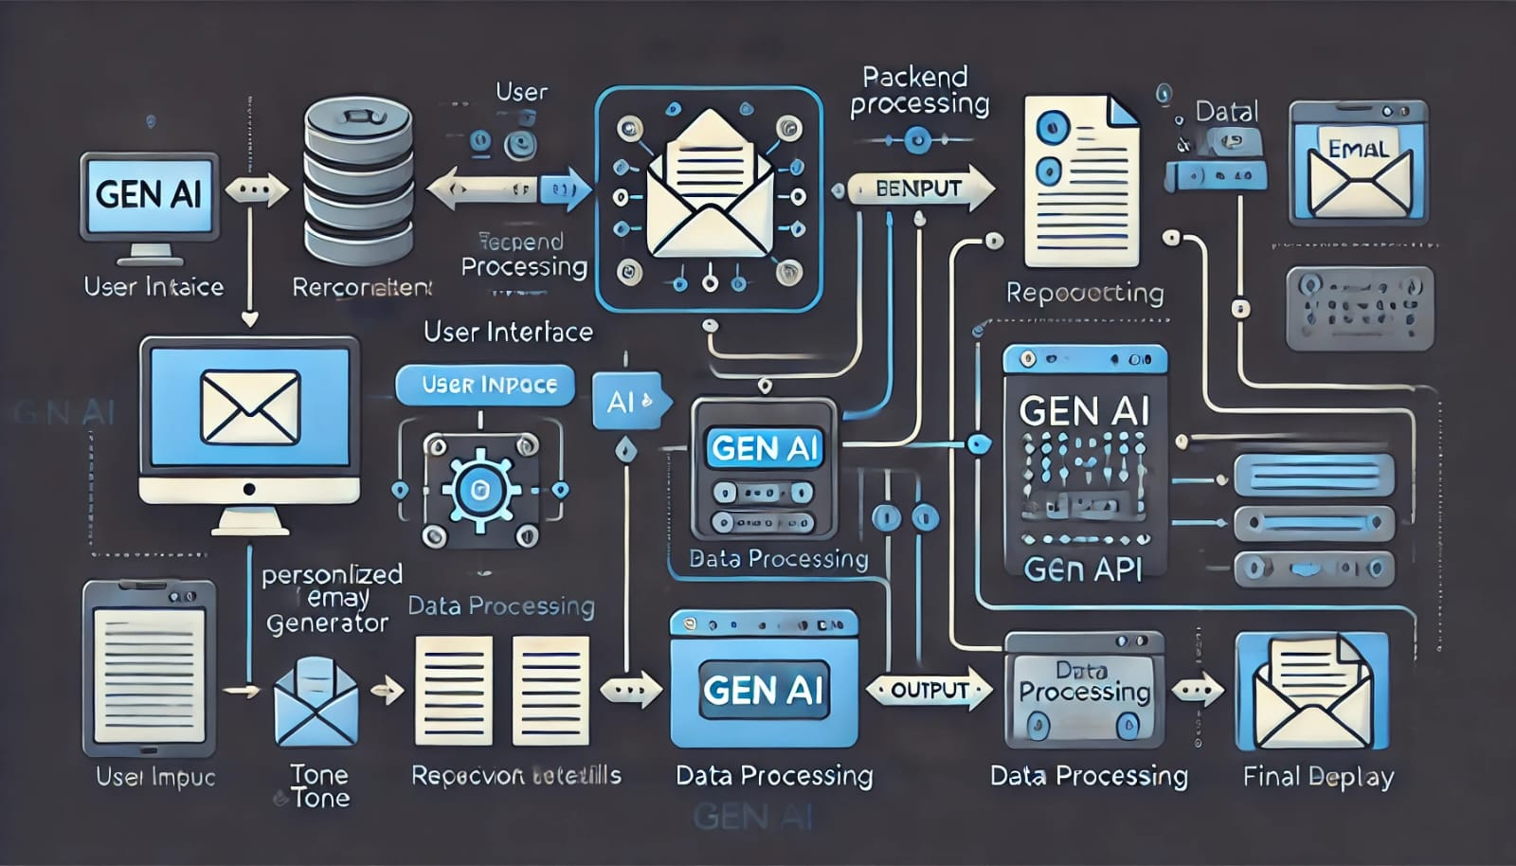

Key Points:
1.System Architecture Diagram:
- Frontend (React/Vue.js): Allows users to log in, select email templates, and customize content.
- Backend (Python/Flask/FastAPI): Handles API requests, processes personalization, and communicates with AI models and databases.
- AI Model (GPT/BERT): Generates personalized email content based on customer data and templates.
- Email Service (SendGrid/Amazon SES) & Analytics Dashboard: Sends emails and tracks performance metrics like open and click-through rates.

2.User Flow:
- Login/Authentication: User logs in to the system for access.
- Select Email Template: User chooses a pre-built or custom email template.
- Customize Content: User edits the email content, adding dynamic variables (e.g., name, product recommendations).
- AI Personalization: Backend calls the AI model to generate personalized email content.

3.UI/UX Considerations:

- User-Friendly Interface: Simplify navigation with easy access to templates, customization, and preview features.
- Responsive Design: Ensure the UI is optimized for all devices (desktop, tablet, mobile).
- Real-Time Feedback: Offer instant updates on email edits, previews, and performance metrics for better user engagement.

Phase-4: Project Planning (Agile Methodologies)

Objective:
  - Break down the tasks using Agile methodologies.

Sprint 1 | User Authentication (Login/Signup) |  | Implement login functionality with user authentication (JWT/Outh). | Priority | Est.time | Owner | Status
Sprint 1 |  | Database Design and Setup | Design the schema for user data, email templates, and customer profiles in PostgreSQL/MongoDB. | High | 5 days | Developer | in Progress
Sprint 2 | Frontend UI for Template Selection |  | Create a UI for users to browse and select email templates. | High | 5 days | Backend Dev | To do
Sprint 2 | AI Model Integration for Personalization |  | Integrate GPT/BERT for generating personalized email content based on customer data. | Medium | 6 days | Frontend Dev | To do
Sprint 3 | Rich Text Editor for Email Customization |  | Implement a text editor (TinyMCE/Draft.js) for users to edit and customize email content. | High | 4 days | AI Specialist | To do
Sprint 3 | Preview Functionality |  | Allow users to preview the personalized email before sending. | Medium | 5 days | Backend Dev | To do
Sprint 4 | Email Sending via API Integration |  | Integrate SendGrid/Amazon SES to send the personalized emails. | High | 6 days | Backend Dev | To do

Phase-5: Project Development

Objective:
  - Code the project and integrate components.

Key Points:
- Technology Stack Used:
- Frontend: React or Vue.js
- Backend: Python with flask API
- Programming Language : Python

- Development Process:
- The development will follow Agile sprints, with each sprint focusing on specific features like user authentication, AI integration, and email delivery.
- Continuous testing and iteration will ensure the system meets user requirements and performs effectively.

- Challenges & Fixes:
- Challenge: Data Privacy & Compliance
Fix: Implement strong encryption, secure authentication (e.g., OAuth), and ensure adherence to GDPR, CCPA, and other data protection regulations.
- Challenge: AI Model Accuracy & Relevance
Fix: Continuously fine-tune the AI model with real-world email data, conduct manual review of outputs, and provide fallback mechanisms for incorrect content.

Phase-6: Functional & Performance Testing

Objective:
  - Ensure the project works as expected.
Test Case ID | Scenario | Performance Testing | API Response Time | Needs Optimization | Tester
TC01 | User Authentication Test | Validate login process under load | < 2 seconds | None | Tester1
TC02 | Email Template Selection | Test UI responsiveness with multiple templates | < 3 seconds | Optimize template loading speed | Tester2
TC03 | AI Personalization | Validate content generation speed | < 5 seconds | AI model response time | Tester3
TC04 | Real-Time Email Preview | Test rendering speed on different devices | < 4 seconds | Improve rendering times | Tester2
TC05 | Email Sending Test | Test email delivery time | < 10 seconds | None | Tester1
TC06 | Performance Tracking | Validate email performance tracking | < 3 seconds | None | Tester3
TC07 | Cross-Device Compatibility | Test UI behavior across devices | < 3 seconds | None | Tester2
TC08 | Security & Data Privacy | Test data encryption during login/signup | N/A | Enhance encryption mechanisms | Tester1
TC09 | Database Operations | Validate read/write performance | < 2 seconds | Optimize DB queries | Tester3
TC10 | API Response Time | Test API under load | < 2 seconds | Optimize API calls | Tester2

Final Submission
- Project Report Based on the templates
- Demo Video (3-5 Minutes)
- GitHub/Code Repository Link
- Presentation

